TERMS AND CONDITIONS
R.G.SPRINGALL ChM FRCS
CONSULTANT GENERAL, GASTROINTESTINAL & COLORECTAL SURGEON

HOURLY FEE £300.00

SCREENING/SHORT FORM REPORT start at £900.00 depending upon volume of records for review

REVIEW OF MEDICAL RECORDS SCRUTINY OF DOCUMENTS 1-2 HOURS PER 300
PAGES

INITIAL MEDICAL REPORT
FOLLOWING REVIEW OF RECORDS DICTATION AND EDITING 1-3 HOURS

RESPONSE TO QUESTIONS OF
INITIAL REPORT £150.00 to £300.00

PREPARATION OF JOINT STATEMENT £150.00

CONSULTATION APPOINTMENT
AND EXAMINATION OF CLIENT £250.00 (half hour) extended over 1 hour will incur additional
IN OUR CONSULTING ROOMS £500.00 (1 hour) charges in half hour increments

FAILURE TO ATTEND APPOINTMENT
WITHOUT NOTIFICATION £250.00

OFFSITE CONSULTATION/ Consultation only - £300.00 see travel costs see below.
DOMICILIARY VISIT

TRAVEL FARE TO BE REIMBURSED – first class rail fare at peak times - standard class rail fare at off peak times /driving
Costs £1.00 per mile £300 per hour travelling time
ATTENDANCE AT CONFERENCE
WITH COUNSEL (TELEPHONE) £150.00 (up to ½ hr - £300.00 up to 1hr)

ATTENDANCE AT TRIAL – 1 DAY £1500.00

ATTENDANCE AT TRIAL – HALF DAY £1000.00

COURT CANCELLATION - FOR £800.00
SHORT NOTICE (within 7 days)

CONTINGENCY FOR UNFORSEEN WORK £300 – hourly rate

SETTLEMENT OF FEES REQUIRED WITHIN 6 MONTHS FROM INSTRUCTION

AVERAGE TURNAROUND FOR REPORTS IS 17 WEEKS FROM INSTRUCTION. THIS CAN INCREASE DURING PERIODS OF HIGH DEMAND PLEASE CONTACT MY OFFICE DIRECTLY FOR CURRENT TURNAROUND TIMES. PREFFERED METHOD FOR RECEIVING INSTRUCTION IS EMAIL AT RGSPRINGALL@GMAIL.COM.OR VIA CD. PAPER INSTRUCTIONS NEED TO BE AGREED WITH MY OFFICE BEFORE FORWARDING MY CLAIMANT/DEFENDANT INSTRUCTION SPLIT IS 80% CLAIMANT/ 20% DEFENDANT AND ON AVERAGE I PRODUCE 50 REPORTS A YEAR. I HAVE INDEMNITY COVER WITH THE MEDICAL DEFENCE UNION

CONSULTATIONS ARE HELD IN MY ROOMS AT 116 HARLEY STREET, LONDON, W1G 7JL.
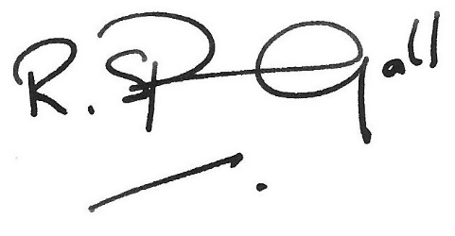

ROGER G SPRINGALL ChM FRCS
CONSULTANT GENERAL, GASTROINTESTINAL & COLORECTAL SURGEON

